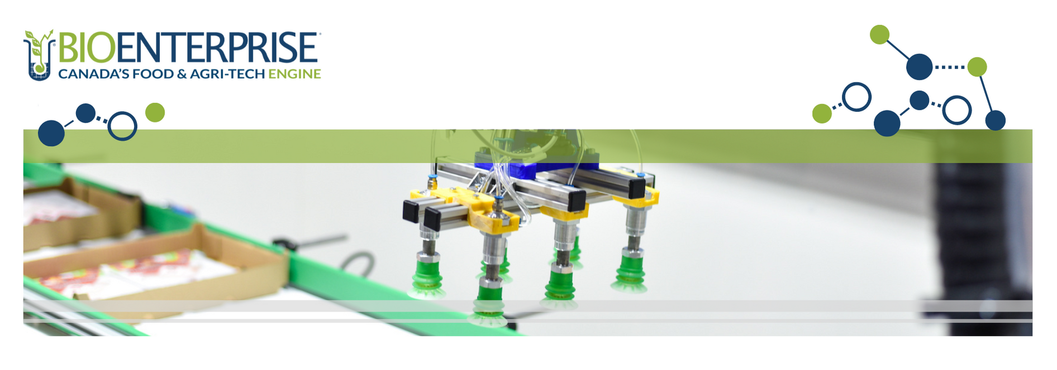

FoodShift Program

Enabling growth by helping southern Ontario-based food & beverage manufacturers deploy Canada’s leading clean technologies

APPLICATION WORKBOOK
Final Intake – September 2023
I. WRITTEN PROPOSAL – FOODSHIFT PROGRAM
SECTION A: FOOD & BEVERAGE PROCESSING ORGANIZATION
Food & beverage processor name
Brief organization description
(400-word max.)

Please include:
- Relevant details such as mission statement, years in operation, location(s), size of operations, etc.
- Short (1-3 years) and long (5+ years) term organizational growth plans

Product(s) overview
(400-word max.)

Please include an overview of your operations and product offerings (i.e., production line(s), range of products, channels to market, export strategy, etc.)

Product manufacturing process(es)
(400-word max.)

Please include:
- Describe the manufacturing processes and capabilities relevant to this application
- Describe any previous technology adoption, integration, or deployment projects OR process optimization consultations. Include activities undertaken, staff trained, economic and environmental outcomes

SECTION B: CLEAN TECHNOLOGY PROVIDER
Clean technology partner name

Indicate the name of the clean technology provider OR the clean technology service provider.

Brief organization description
(250-word max.)
Please include:
- A brief organizational overview (mission statement, years in operation, etc.)
- Describe the organization’s current and future target market(s) (optional)

Brief technology description OR overview of the service offering
(200-word max.)

Briefly describe the technology to be adopted, implemented, or deployed in your organization’s operations OR describe the consultation service being provided to the applicant.

Technology Readiness Level (TRL) of the clean technology  Select one only (*if applicable – in the case that a clean technology is being adopted or integrated). | 8 – Technology completed and qualified through testing and demos  9 – Actual technology proven through successful deployment in an operational setting
Examples of where this clean technology has been previously implemented (other industrial end-users) *if applicable
If confidential, please describe the use case in general terms.

SECTION C: DETAILED PROJECT OVERVIEW
Project title
Project start date
Project end date
Project rationale
(200-word max.)

Please include the strategic importance of this project for your organization in general, and how it will support your organization’s transition to a green economy and/or net-zero future

Rationale for clean technology partner selection
(100-word max.)

Why was this specific technology selected for implementation in your operations? How will it help you achieve your project outcomes?
Detailed project overview & implementation
(600-word max.)

Please include:
a) A detailed overview of the project activities and objectives
b) A clear explanation of the scope and resources required to complete the project
c) Geographic location in Ontario where the project will take place

SECTION D: PROJECTED OUTCOMES
Environmental outcomes  (300-word max.)  Describe and provide an estimate on how this project will improve your organization’s environmental metrics. Include both baseline (where available) and post-technology implementation (2-years) outcomes in the relevant metrics listed. | Metric* Baseline/Best current approximation Post-Technology Implementation (2-years after project is completed)  Greenhouse gas (GHG) emissions  Water management  Energy conservation  Food loss and waste generation (i.e., discarded or diverted – not used by the manufacturer)  Green energy use (i.e, solar, wind, etc.)  Other  *Where available. Only include information on the relevant metrics listed.
Does your organization have GHG reduction targets?

If yes, what scope(s) (scope 1, 2, and 3) and level are included in your targets? What national or international standard(s) or initiative(s) does your organization currently utilize for its reduction targets? How will this project help you achieve your targets?

If no, does your organization have plans to implement GHG reduction targets in the next two years?

Carbon offset credits
(100-word max.)

Are you currently involved, or plan on becoming involved through this project, in any carbon offset credit programs?
Jobs created & maintained  (REQUIRED)  List any direct jobs created (i.e., a job that did not exist within the organization prior to the project but was created as a direct result of the project) and jobs maintained (i.e., a job that existed within the organization prior to the project but would not continue if the project is not funded.)  These apply to the project period as well as two years post project completion. | Food and Beverage Processing Organization  Type # of Permanent FTEs # of Temporary FTEs # of Permanent PTEs # of Temporary PTEs  Created  Maintained  Clean Technology Provider  Type # of Permanent FTEs # of Temporary FTEs # of Permanent PTEs # of Temporary PTEs  Created  Maintained  FTE = full-time equivalent  PTE = part-time equivalent
Organization revenue generation
(100-word max.)

Provide projected revenue growth as a result of project completion over a 2–4-year period. Please provide either as dollar amount or as incremental revenue growth (%).

Intellectual Property (IP)*
(100-word max.)

New IP generated through project completion and/or any filing related to the new IP (i.e., patent, trademark, industrial design, or copyright activities).
*if applicable

United Nations Sustainable Development Goals (SDG)*  Will your project address any of the UN’s SDGs?  *Optional, please select any that are relevant. | 2 – Zero hunger  3 – Good health and well-being  6 – Clean water and sanitation  7 – Affordable and clean energy  8 – Decent work and economic growth  9 – Industry, innovation, and infrastructure  11 – Sustainable cities and communities  12 – Responsible consumption and production  13 – Climate action  14 – Life below water  15 – Life on land  Not listed:

SECTION E: PROJECT TEAM & PARTNERS
If you are hiring new staff to execute the project, indicate the “name” as “new hire”.

Food and Beverage Processing: Project Team Members (required)

Name | Position | Role, expertise, and participation in project

Clean Technology Partner: Project Team Members (required)

Name & Organization | Position | Role, expertise, and participation in project

Partners and/or Suppliers: External Project Team (optional, if applicable. If you would like this group to be informed of application decisions please include an email address)

Name & Organization | Position & Email Address | Role, expertise, and participation in project

SECTION F: IMPLEMENTATION PLAN
Risk assessment and proposed mitigation strategy
(300-word max.)

Address any risks related to timeline, financial, environmental & technical aspects of the project.

Total project budget | $
Total funding requested  (Max. 50% of total eligible project budget; up to $50,000) | $
Sources of matching funding to execute all project activities
List sources of matching funding that will be used towards completing this project.
(Matching funding of up to $50,000, plus the budget balance, if applicable)

Project milestone plan | See Part II – Project Milestone Plan (below)
Project budget | See Part III – Budget Workbook (excel document)
Date submitted

II. PROJECT MILESTONE PLAN
ACTIVITY TITLE  List each activity below in chronological order and correlate to Part III – Budget.  Add more activities as needed. |  | START DATE  (YYYY-MM-DD)  *Earliest start date is 2022-06-10 | END DATE  (YYYY-MM-DD)  *Latest end date is 2024-03-31 | ACTIVITY DESCRIPTION  Provide details of what is to be included in the activity. List the key project partners involved in each activity. Indicate where the activity will take place and who will be involved. | OUTCOMES  Articulate expected outcomes for each Activity, including the impact on the overall project.
1.
2.
3.
4.
5.
6.

III. BUDGET
Please refer to and complete the Budget Workbook.
Please submit your Application Workbook, Budget Workbook, and appendices (as outlined below) online using this link: FoodShift: Application Form
APPENDICES
*Please include all items in .pdf format
Required Financial Appendices | Two (2) years of financial statements reviewed and reported on by an independent external accountant with a minimum “Notice to Reader Report” (required)  Internally prepared financial statements for the current fiscal year to the date of application submission (required)
Required Clean Technology Statement of Work | This document will either:  - Outline the eligible clean technology provider’s technology to be commissioned by the applicant (in the case that a clean technology is being adopted or integrated in the applicant’s facility). This document must include: the TRL of the clean technology to be implemented (must be at minimum 8+), technology specifications, detailed project implementation activities, costs, and timeline, and provider deliverables and project outcomes; or  - Outline the scope of work the eligible clean technology service provider will be completing as part of the project. This document must include a detailed list of project activities, costs, and timelines, and provider deliverables and project outcomes.
Optional Appendices  (Recommended if available) | Environmental, Social, and Governance (ESG) Report or similar document(s)  Letters of Support of need and/or potential for commercial adoption of technology

