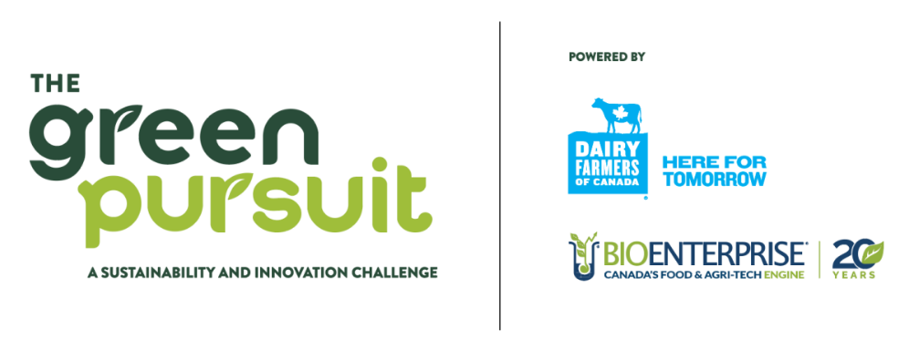

The Green Pursuit, a Sustainability and Innovation Challenge

Frequently Asked Questions (FAQs)

Q. Who can apply?
- Canadian incorporated and headquartered for-profit business
- Majority owner(s) (51% or more) of the company plan to work full-time within the business
- Minimum Technology Readiness Level 4+ (Component and/or validation in a laboratory environment - basic technological components are integrated to establish that they will work together)
  - See TRL Level guidelines here
- Operating in ag-tech or food-tech sectors and provide a benefit to or solve a sustainability problem for the broader agriculture and/or food & beverage producer sectors in Canada
  - Specific areas of focus are: Carbon Footprint, Regenerative Agriculture, Biodiversity, Energy, Plastics
- If revenue generating - trailing 12 months revenue must not exceed $250,000
- Must have 5 or fewer FTE employees

Q. What is Bioenterprise’s confidentiality policy?
Bioenterprise operates under a strict confidentiality policy. Any documentation shared will be treated as highly confidential. Please click here to review the policy.

Q. When is the application deadline?
The application deadline is June 17, 2023 at 12:00PM EST.

Q. How much prize money is available?
The entire purse for the challenge is $50,000 Canadian dollars, to be distributed as $45,000 to the winner and $5,000 to the runner up.

Q. Can an entrepreneur/team submit an application for multiple companies?
Yes, applicants with multiple & distinct qualifying corporate entities can submit multiple applications but only one per entrepreneur/team could be selected as a finalist.

Q. How are applications ranked against each other to determine the finalists who will present at the live event?
All applications will be scored against a standardized rubric by a panel of experts, and 10 highest scoring applications will be selected. In the event of ties the expert panel will set aside a half-day session to discuss and adjudicate based on the standardized rubric and come to a majority vote.

Q. What is the Technology Readiness Level (TRL) scale? How do I determine the TRL of my technology?
The TRL scale helps categorize a technology’s development stages, from Level 1 (Concept Evaluation) to Level 9 (Successful Deployment). The Green Pursuit Challenge will only consider projects that implement or adopt technologies that are at minimum TRL 4+. To determine the TRL of your technology, click here.

Q. How will the prize money be distributed?
The winner and runner up will receive a cash payment in the form of a wire directly to their corporate bank account.

Q. Are there any equity or debt considerations?
No - this competition does not seek to engage in an equity or debt holding position in any participant companies. The winner and runner up will simply receive cash prizes.

Q. Are there any ongoing reporting requirements for cash prize winners?
No - we will not require any ongoing reporting of company news, information, etc.

Q. Does my company have to do work in the dairy farming industry to be eligible?
No - applications are encouraged from across the agriculture, ag-tech, food and beverage, and food-tech spectrum.

Q. What do you mean by “sustainability”?
There are many definitions of “sustainability” but specific to this competition we are looking for applicants who have a technology with a clear and direct impact within one of the Dairy Farmers of Canada key Sustainability Focus Areas: Carbon Footprint, Regenerative Agriculture, Biodiversity, Energy, Plastics.

Key Dates

May 17th, 2023
Rolling application intake opens

June 17th, 2023 at 12:00pm EST
Application period closes

July 30th, 2023
Finalists are selected and notified by this date or earlier

August 1st – 31st, 2023
Mock pitches and feedback for finalists

TBD Early October, 2023
Virtual pitch event

