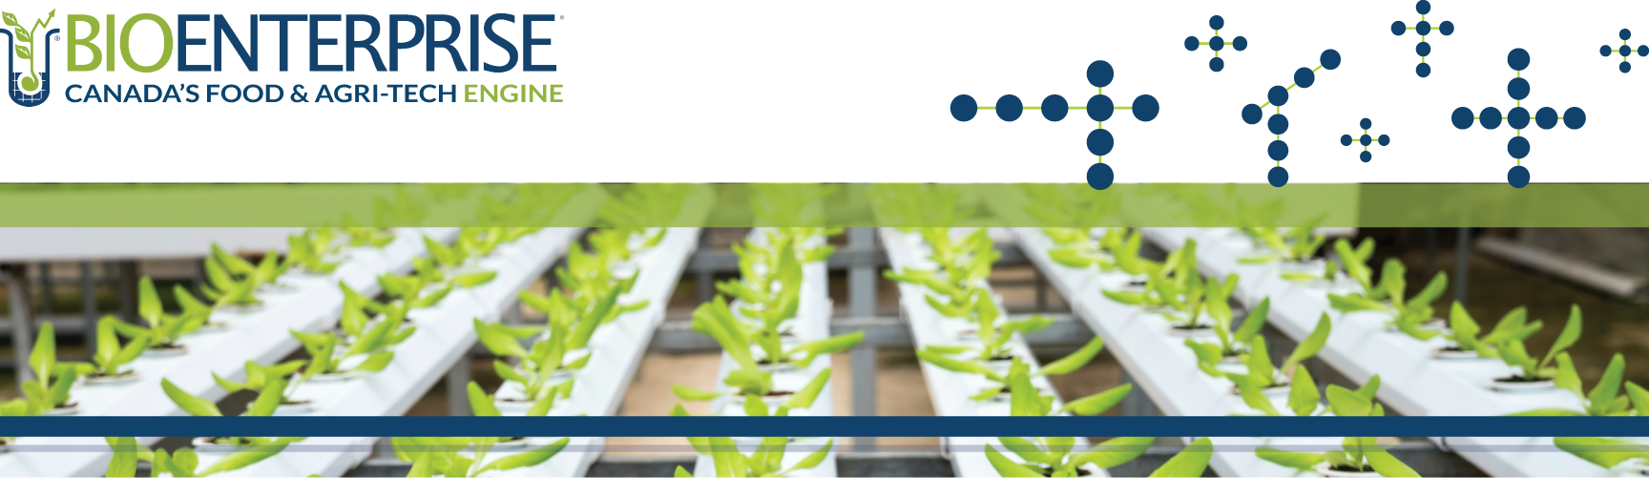

SmartGrowth Program

2022-23 LETTER OF INTENT (LOI) WRITTEN PROPOSAL

LETTER OF INTENT WRITTEN PROPOSAL – SMARTGROWTH PROGRAM
SECTION A: COMPANY & PRODUCT/TECHNOLOGY OVERVIEW
Company Name
Brief company description
(200-word max.)

Please include:
a) A brief overview of company and the product/technology
b) An explanation of how your company benefits or supports the Canadian agricultural industry

Brief technology/product description & value proposition
(200-word max.)

Briefly describe your current understanding of the value proposition of your product in the eyes of the customer.

What problem are you trying to solve in the market?

Please note, if your company has more than one technology or product, please briefly describe your product portfolio, but focus on the innovation that will be advanced through this project.

Describe how your product/technology is uniquely solving the identified problem
(200-word max.)

Describe innovation in terms of product, process, marketing, and organization.

Describe the uniqueness of your innovation.

Technology Readiness Level (TRL) of the product/technology that will be advanced through this project  Select one only. | 6 – System model or prototype demonstrated in simulated environment  7 – Prototype ready for demonstration in an operational environment  8 – Technology completed and qualified through testing and demos  9 – Actual technology proven through successful deployment in an operational setting
List the three (3) most important achievements that demonstrate the current TRL of your product/technology  (50-word max. per point) | 1 -  2 -  3 -
SECTION B: HIGH-LEVEL PROJECT OVERVIEW
Project Title
Project Start Date
Project End Date
Project Overview
(300-word max.)

Provide a high-level overview of anticipated project activities and objectives.

Highlight the strategic importance of this project for your company’s growth.

Provide a brief overview of the project team including partner organizations.
Project Outcomes
(100-word max.)

In point form, please list the impact the proposed project will have on job creation, revenue generation, new IP generation, and/or attracting new investment.

SECTION C: HIGH-LEVEL PROJECT BUDGET
Total Project Budget by Activity
(200-word max.)

Provide an overview of the project activities and related costs. Include both eligible and ineligible costs.

Total Project Budget | $
Total Funding Requested  (max. 40% of total eligible project budget; min. $40K, max. $100K) | $
Does the company have the remaining funds available to execute the project?  (min. 60% of total eligible project budget) | YES NO
Other Funding Sources

List other sources of funding that will be used towards completing this project.

Date Submitted

