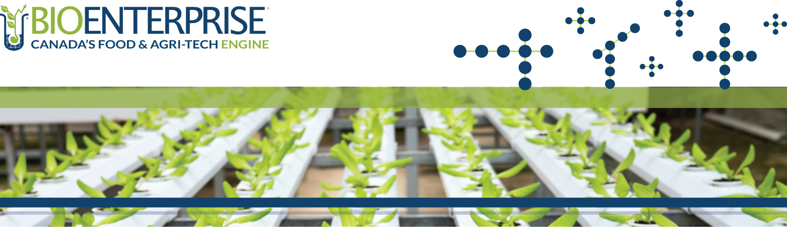

SmartGrowth Program

2021-22 LETTER OF INTENT (LOI) WRITTEN PROPOSAL

LETTER OF INTENT WRITTEN PROPOSAL – SMARTGROWTH PROGRAM
COMPANY INFORMATION:
Company Name
Brief Company Description
(500-word max.)

Please include:
a) Brief company overview
b) An explanation of your company’s product/technology/service
c) An explanation of how your company benefits or supports the Canadian agricultural industry

Describe the problem your product/technology/service is solving
(250-word max.)

Describe how your product/technology/service is uniquely solving this problem
(250-word max.)

Describe innovation in terms of product, process, marketing and organizational uniqueness to the region, in Ontario, or beyond.

SECTION A: HIGH-LEVEL PROJECT OVERVIEW
Project Overview
(500-word max.)

Provide a high-level overview of anticipated project activities and objectives.

Highlight the strategic importance of this project for your company’s growth.

Project Outcomes
(200-word max.)

What impact will the proposed project have on job creation, revenue generation, and/or attracting new investment?

SECTION B: OVERVIEW OF PROJECT TEAM
Project Team & Partners
(300-word max.)

Provide a brief overview of the company’s leadership team that will execute the project.

Describe the role of partner business/organization and their product/services. What is their involvement in regard to the project? (if applicable)

*Please note that project partners must be at arm’s length from your company.

SECTION C: HIGH-LEVEL PROJECT BUDGET
Project Budget
(300-word max.)

Provide an overview of how the funding will be used. Include anticipated expenses relating to each activity.

Highlight any funding support being used towards this project from other sources.
Total Project Budget

Total Funding Requested
(max. 40% of total budget; min. $40K, max. $100K)
Date Submitted

